[DCO-2419] All Channels - Authenticated Signers Show Password fields Contrast Issues Created: 30/Apr/24 Updated: 06/May/24
Status: | In External Review
Project: | Journey Manager
Components: | None
Affects versions: | None
Fix versions: | Accessibility

Type: | Story | Priority: | None
Reporter: | Sanya Khandhuja | Assignee: | Fusi Olateru
Resolution: | Unresolved | Votes: | 0
Labels: | Business-self-serve, Motive, MotiveAuthenticated, Personal-self-serve
Remaining Estimate: | Not Specified
Time Spent: | Not Specified
Original estimate: | Not Specified

Attachments: | image-20240430-133032.png
QA Bug Count: | 0
Days Open: | 3 days
Bug Count: | 0
Hours Variance: | 0
Hours Remaining: | 0
Hours Target PMO: | 0
Sprint:
Days Open: | 2

Description

The show password user interface component has contrast between foreground and
background that is insufficient (1.5:1); falling short of the 3:1 contrast ratio required.
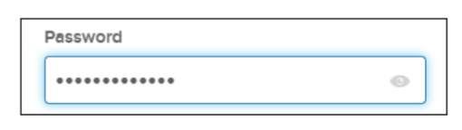
■ Recommendation: Change all problematic foreground/background pairings to higher
contrast ratios that meet or exceed the required minimum of 3:1 for informational
icons.

Comments

Comment by Fusi Olateru [ 03/May/24 ]
we cannot change this as well.
Generated at Mon May 06 21:49:37 UTC 2024 by Ian Hicks using Jira 1001.0.0-SNAPSHOT#100252-rev:aa264b414382dcd2bbea0c3e63c78e358e7de0d5.

